|  |
| --- |
|  |
| Q/d*C |
| MANE-VU Updated Contribution Assessment |
|  |
| **MANE-VU** |
| **4/6/2016** |

|  |
| --- |
|  |

Contents

Figures i

Tables i

Background and Introduction 1

Methods 1

Results 4

State Population Weighted Centroid Analysis (State Totals & Comparison to 2012 Analysis): 4

2011 Point Source Analysis 6

Projected 2018 Contribution Estimates 9

Conclusions 19

### Figures

Figure 1. Receptors for the 2015 Ci(Q/d) Analysis 2

Figure 2. 2013-2014 Monitored Extinction on 20 Haziest Days, Expressed as Percentage of Extinction 3

Figure 3. Wind Sector Constants and the State Total Emissions and the Locations 8

Figure 4. Wind Vectors Point Source Emissions and Their Locations (2011 Emissions) 8

Figure 5: Average and maximum state point source contribution to monitored class I areas for 2011 and 2018 10

Figure 6. Total point contributions (and percent of total contribution in labels) for 2011 actual and 2018 projections for state in OTC modeling domain. 11

Figure 7: Impact on Class 1 Areas by Point Sectors 16

Figure 8: Relative Impact on Class 1 Areas by Point Sectors 17

Figure 9: Relative Impact of EGU Point Source SCCs on Acadia, Brigantine, Great Gulf, Lye Brook, and Moosehorn (inner to outer) 18

Figure 10. 2011 and 2018 Point Emissions 20

### Tables

Table 1. Top Five Contributing U.S. States for Total State SO2 Emissions over the Three Analyses 4

Table 2. Comparison of State Emissions Contributions from 2007 Emissions and 2011 Emissions. 6

Table 3. Top Five Ranking Contributing States of Point Only and Population Weighted Centroid Methodology 7

Table 4. States with the Five Greatest Point Contributions in 2011 and Projected for 2018 9

## Background and Introduction

The following analysis is a simplified method for estimating sulfate contributions to a receptor, known as the emissions over distance (Q/d) method. Q/d is largely accepted as a screening tool and continues to be as in the conclusion of a July 2015 report by an interagency air quality modeling work group.[1] NESCAUM previously employed this method in the *Contribution to Regional Haze in the Northeast and Mid-Atlantic United States*[2] and the *Contributions to Regional Haze in the Northeast and Mid-Atlantic United States: Preliminary Update Through 2007[3]*.

This assessment primarily uses the methodology as in these previous two studies, any variances from the method are noted in the methods section below. MANE-VU states discussed various options for determining the largest contributors for opening discussions and employing further analysis; including, but not limited to, further CALPUFF modeling. A review of contribution analyses conducted by MANE-VU, including the previous two NESCAUM Q/d studies (CALPUFF analyses and REMSTAD analysis2,3) found similar results regardless of the method. It was decided the most cost effective tool for the first iteration of contribution analysis was the Q/d approach as the resource investment was less than the others and each method previously run provided similar ranking results.

## Methods

The 2015 analysis was done using the ARC MAP ® software with some custom visual basic scripts; scripts are noted in Appendix B. The intent of this approach was to provide a simple exercise that could be repeated with little effort as the project evolved; to better test new methods and investigate new sources of haze; all while providing the data and illustrative graphics in a single effort.

The empirical formula that relates emission source strength and estimated impact is expressed through the following equation:

*I*  *Ci* *Q* / *d* 

In this equation, the strength of an emission source, Q, is linearly related to the impact, I, that it will have on a receptor located a distance, d, away. As in the previous analysis, distances were computed using the Haversine function, using an earth radius of 6371 km2. The effect of meteorological prevailing winds can be factored into this approach by establishing the constant, Ci, as a function of the “wind direction sectors” relative to the receptor site.

By establishing a different constant for each wind direction sector, based on prior modeling results—in this case, CALPUFF results—are in effect “scaling” Q/d results by CALPUFF-calculated source impacts. The absolute impacts produced are then dependent on the CALPUFF results. The relative contributions, however, of each source within a wind direction sector is established completely independent of the CALPUFF calculation, yielding a quasi-independent method of apportionment to add to the weight-of-evidence approach.

Discussion occurred as to whether the wind direction sectors changed to such an extent that updating the data with more recent data was necessary. A consensus of MANE-VU states determined that on average the directions of prevailing winds had not changed and thereby it was still acceptable to utilize the CALPUFF derived constants in the NESCAUM, 2002 analysis. These constants can be noted in Appendix A. As was done in the NESCAUM 2012 analysis state total emissions were evaluated from a source location of a population weight state centroid. Again little change was expected between the locations of the 2012 and 2015 estimated population densities thus the analysis was repeated with the locations of the centroids used in the NESCAUM 2012 study, also noted in detail in Appendix A.

The MANE-VU Class I areas with Interagency Monitoring of Protected Visual Environments (IMPROVE) monitors; Acadia, Brigantine, Great Gulf, Lye Brook & Moosehorn and several near-by Class I areas with IMPROVE monitors; Dolly Sods, James River Face and Shenandoah were used as receptors. The only new receptor in this analysis was the James River Face Wilderness area as it is in close enough in proximity to MANE-VU states it may be important receptor to MANE-VU states emissions (assumptions made to incorporate this receptor using the previous constants are explained in detail in Appendix B). See Figure 1 for locations of receptors analyzed in the 2015 analysis.

The geographic domain varied from the previous studies in that Canadian emissions were excluded this time. The remainder of the domain was the same and consistent with the regions modeling domain for other pollutant planning efforts.

Figure 1. Receptors for the 2015 Ci(Q/d) Analysis

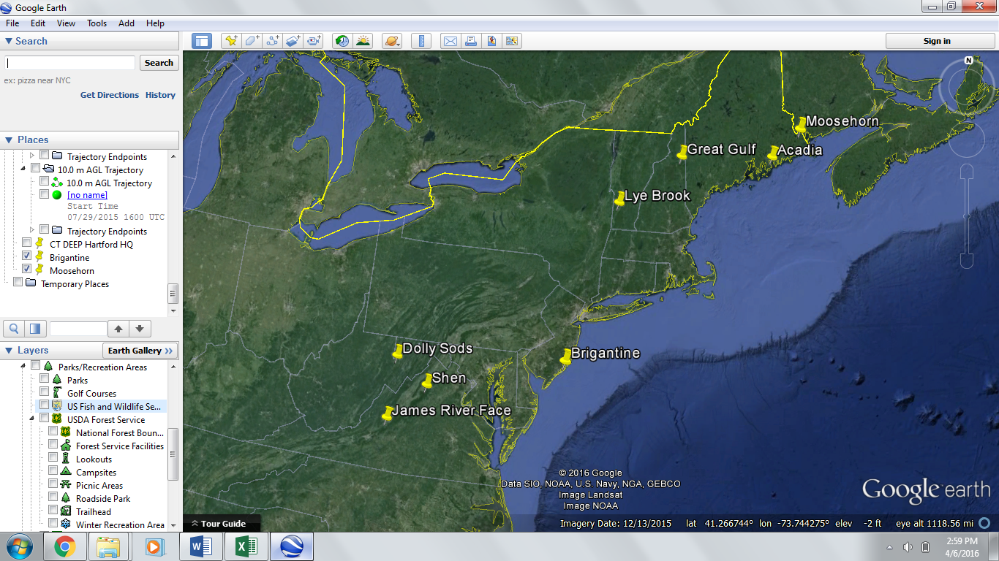

Sulfur dioxide (SO2) emissions from 2011 NEI version 2 were summed for each state across all sectors with the exception of biogenic. This is consistent with the NESCAUM 2012 analysis. However, in the 2015 analysis additional experimental runs were done with volatile organic carbons (VOC), direct fine particulates (PM2.5) and nitrogen oxides (NOX). With the exception of PM2.5 the same methodology was employed (PM2.5 emissions were instead divided by distance squared, as Gaussian dispersion equation indicates is appropriate). A “step by step” documentation of this process can be found in Appendix B.

It was determined that the Ci’s, originally derived for the SO2 emissions, were not appropriate substitutions for these other pollutants; this was most evident in the resulting over estimation of the impact of NOX at the Class I areas with this methodology. This, in addition with the visibility assessment which also showed the relative importance of sulfates compared to other pollutants in regards to light extinction at the IMPROVE sites analyzed (see Figure 2), led us to conclude that SO2 was the most accurate and most relevant estimation for determining the impact of states’ emissions to the visibility impairment of the MANE-VU Class I areas.

Figure 2. 2013-2014 Monitored Extinction on 20 Haziest Days, Expressed as Percentage of Extinction

In addition to exploring the other haze causing pollutants, the 2015 analysis also reviewed the point only portion of the 2011 NEI v2 emissions. The methodology for this is also outlined in appendix B and followed the same general principles. The Ci(Q/d) for the individual sources were summed for each state. The intent behind this analysis was to evaluate a possibly more accurate method, as Q/d is generally accepted for a screening tool for individual sources. In addition, this provided an understanding of the relative importance of a state’s point only contribution to the total contribution of a state. Furthermore, the data from the point source analysis, prior to summation, is useful for later source specific control analyses.

The point analysis was run only with respect to SO2 emissions. It was determined that it is also of value to run an additional analysis of the 2018 projected emissions for the point sources. The MARAMA α2 2018 was the base for the projected point inventory analysis. The 2018 analysis did not include the area and mobile sectors as the four-factor emissions inventory analysis determined that point sources were the overwhelming source of SO2 emissions.[4]

## Results

### State Population Weighted Centroid Analysis (State Totals & Comparison to 2012 Analysis):

For all of the analyses historical and current, Ohio was determined to be one of the top two contributors for all of the eight Class I areas reviewed. Pennsylvania also continues to be one of the top three for seven of the eight receptors. The majority of the top five contributors were very similar to the previous analysis, however significant reshuffling of the top five is apparent indicating the emissions reductions achieved were not equally applied among the neighboring states, see Table 1.

Table 1. Top Five Contributing U.S. States for Total State SO2 Emissions over the Three Analyses

| **Class I Area (Receptor)** | **Rank** | **2002 Analysis**  **(2002 emissions)** | **2012 Analysis**  **(2007* emissions)** | **2015 Analysis**  **(2011 emissions)** |
| --- | --- | --- | --- | --- |
| Acadia | 1 | Pennsylvania/Ohio | Pennsylvania | Ohio |
| 2 | Ohio | Pennsylvania |
| 3 | New York | Indiana | Indiana |
| 4 | Indiana | Michigan | Michigan |
| 5 | West Virginia/ Massachusetts | Georgia | Illinois |
| Brigantine | 1 | Pennsylvania | Pennsylvania | Pennsylvania |
| 2 | Ohio | Maryland | Ohio |
| 3 | Maryland | Ohio | Maryland |
| 4 | West Virginia | Indiana | Indiana |
| 5 | New York | West Virginia | Kentucky |
| Dolly Sods | 1 | New to 2007 analysis, no 2002 data | Pennsylvania | Ohio |
| 2 | Ohio | West Virginia |
| 3 | West Virginia | Pennsylvania |
| 4 | Indiana | Indiana |
| 5 | North Carolina | Kentucky |
| Great Gulf | 1 | Analysis not done | Pennsylvania | Ohio |
| 2 | Ohio | Pennsylvania |
| 3 | Indiana | Indiana |
| 4 | Michigan | Michigan |
| 5 | New York | Illinois |
| James River Face | 1 | New to analysis not available for earlier years | | Ohio |
| 2 | Pennsylvania |
| 3 | Indiana |
| 4 | Kentucky |
| 5 | West Virginia |
| Lye Brook | 1 | Pennsylvania | Pennsylvania | Pennsylvania |
| 2 | Ohio | Ohio | Ohio |
| 3 | New York | New York | Indiana |
| 4 | Indiana | Indiana | New York |
| 5 | West Virginia | Michigan/West Virginia | Michigan |
| Moosehorn | 1 | Pennsylvania/ Ohio | Pennsylvania | Ohio |
| 2 | Ohio | Indiana |
| 3 | Indianan/New York | Indiana | Illinois |
| 4 | Michigan | Michigan |
| 5 | Michigan | Texas/Missouri/Illinois/West Virginia/New York | Texas |
| Shenandoah | 1 | Ohio | Pennsylvania | Ohio |
| 2 | Pennsylvania | Ohio | Pennsylvania |
| 3 | West Virginia | West Virginia | Indiana |
| 4 | North Carolina | Maryland | West Virginia |
| 5 | Maryland | Indiana | Virginia |

*Note: Cells with more than one source state/territory indicate equal values.  
\** The 2012 analysis uses 2008 NEI emissions, 2007 NPRI point source emissions and 2009 NPRI area and mobile source emissions. (See table 2-1 of the report NESCAUM, 2012)

Table 2, displays the quantitative contributions to the MANE-VU and neighboring Class I areas between the 2012 analysis (2007 emissions) and the 2015 (2011 emissions).

Table 2. Comparison of State Emissions Contributions from 2007 Emissions and 2011 Emissions.



### 2011 Point Source Analysis

The analysis was completed for the 2011 NEI v2 point inventory. Table 3, displays the top five ranks states with but the 2011 population weighted centroid SO2 emissions and the point only SO2 emissions in the Ci (Q/d) method. Highlighted cells indicate states that varied in their ranks between the analyses. Two of the eight Class I areas saw a significant difference in the rankings; Brigantine and Moosehorn. The relative quantities displayed in Table 3 also indicate that the point sources are still a significant portion of each state’s contributions with respect to SO2 emissions. Figures 3 and 4 below clarify how the evaluation of the contributions by individual source or state total with population centroid approach can alter the results, using Brigantine as an example. The analysis when done by on an individual source places each source with in different vector constants, theoretically more accurate approach especially with the intent to consider individual source contributions in further analyses.

Table 3. Top Five Ranking Contributing States of Point Only and Population Weighted Centroid Methodology

|  |  |  |  |  |  |
| --- | --- | --- | --- | --- | --- |
| **2011 Point Top 5 Contributions** | | | **2011 Centroid Top 5 Contributions** | | |
| Receptor | State | Contribution | Receptor | State | Contribution |
| **Acadia** | OH | 0.091941355 | **Acadia** | Ohio | 0.110722 |
| PA | 0.065000429 | Pennsylvania | 0.076393 |
| IN | 0.050261661 | Indiana | 0.056531 |
| MI | 0.042254566 | Michigan | 0.043586 |
| IL | 0.031767801 | Illinois | 0.035447 |
| **Brigantine** | OH | 0.143782214 | **Brigantine** | Pennsylvania | 0.144185 |
| PA | 0.127168402 | Ohio | 0.122695 |
| IN | 0.060995943 | Maryland | 0.062602 |
| KY | 0.048691472 | Indiana | 0.054433 |
| TX | 0.03855251 | Kentucky | 0.051057 |
| **Dolly Sods** | OH | 0.304332742 | **Dolly Sods** | Ohio | 0.285194 |
| PA | 0.156460896 | West Virginia | 0.140909 |
| WV | 0.121920177 | Pennsylvania | 0.13217 |
| IN | 0.091857237 | Indiana | 0.096535 |
| KY | 0.069838976 | Kentucky | 0.070214 |
| **Great Gulf** | OH | 0.073746721 | **Great Gulf** | Ohio | 0.097926 |
| PA | 0.052415185 | Pennsylvania | 0.062172 |
| IN | 0.045361066 | Indiana | 0.048236 |
| MI | 0.035254865 | Michigan | 0.038705 |
| IL | 0.027097205 | Illinois | 0.029948 |
| **James Face** | OH | 0.220751954 | **James Face** | Ohio | 0.148042 |
| PA | 0.093719295 | Pennsylvania | 0.095895 |
| IN | 0.084795405 | Indiana | 0.085382 |
| KY | 0.06977157 | Kentucky | 0.070312 |
| VA | 0.055890047 | West Virginia | 0.067112 |
| **Lye Brook** | OH | 0.114401027 | **Lye Brook** | Pennsylvania | 0.132424 |
| PA | 0.098398004 | Ohio | 0.116413 |
| IN | 0.051105607 | Indiana | 0.05447 |
| MI | 0.044568087 | New York | 0.053722 |
| NY | 0.032786194 | Michigan | 0.044304 |
| **Moosehorn** | OH | 0.08457113 | **Moosehorn** | Ohio | 0.079613 |
| PA | 0.053933613 | Indiana | 0.057955 |
| IN | 0.047024234 | Illinois | 0.036654 |
| MI | 0.038105112 | Michigan | 0.030354 |
| IL | 0.031793931 | Texas | 0.029351 |
| **Shenandoah** | OH | 0.223136587 | **Shenandoah** | Ohio | 0.205847 |
| PA | 0.129388586 | Pennsylvania | 0.14796 |
| IN | 0.07666613 | Indiana | 0.079393 |
| WV | 0.063798543 | West Virginia | 0.079183 |
| KY | 0.057891393 | Virginia | 0.068504 |

Figure 3. Wind Sector Constants and the State Total Emissions and the Locations

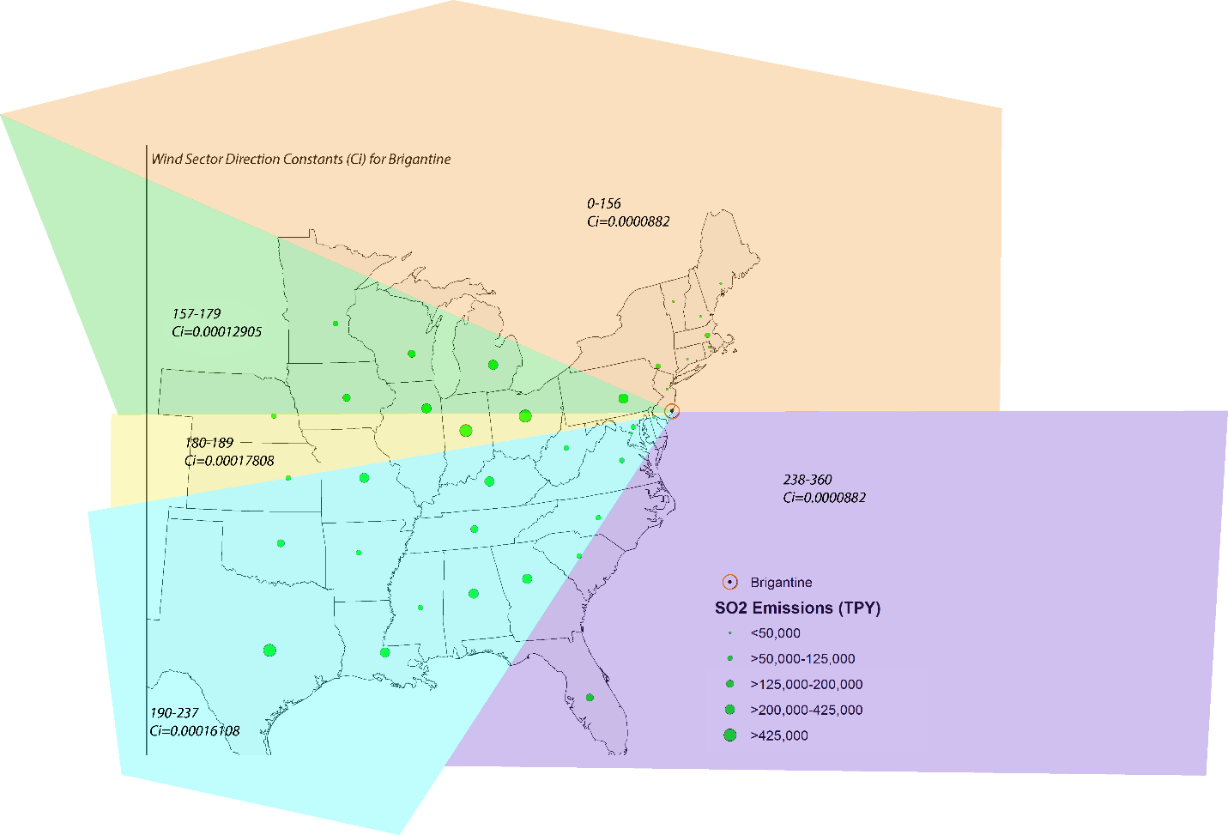

Figure 4. Wind Vectors Point Source Emissions and Their Locations (2011 Emissions)

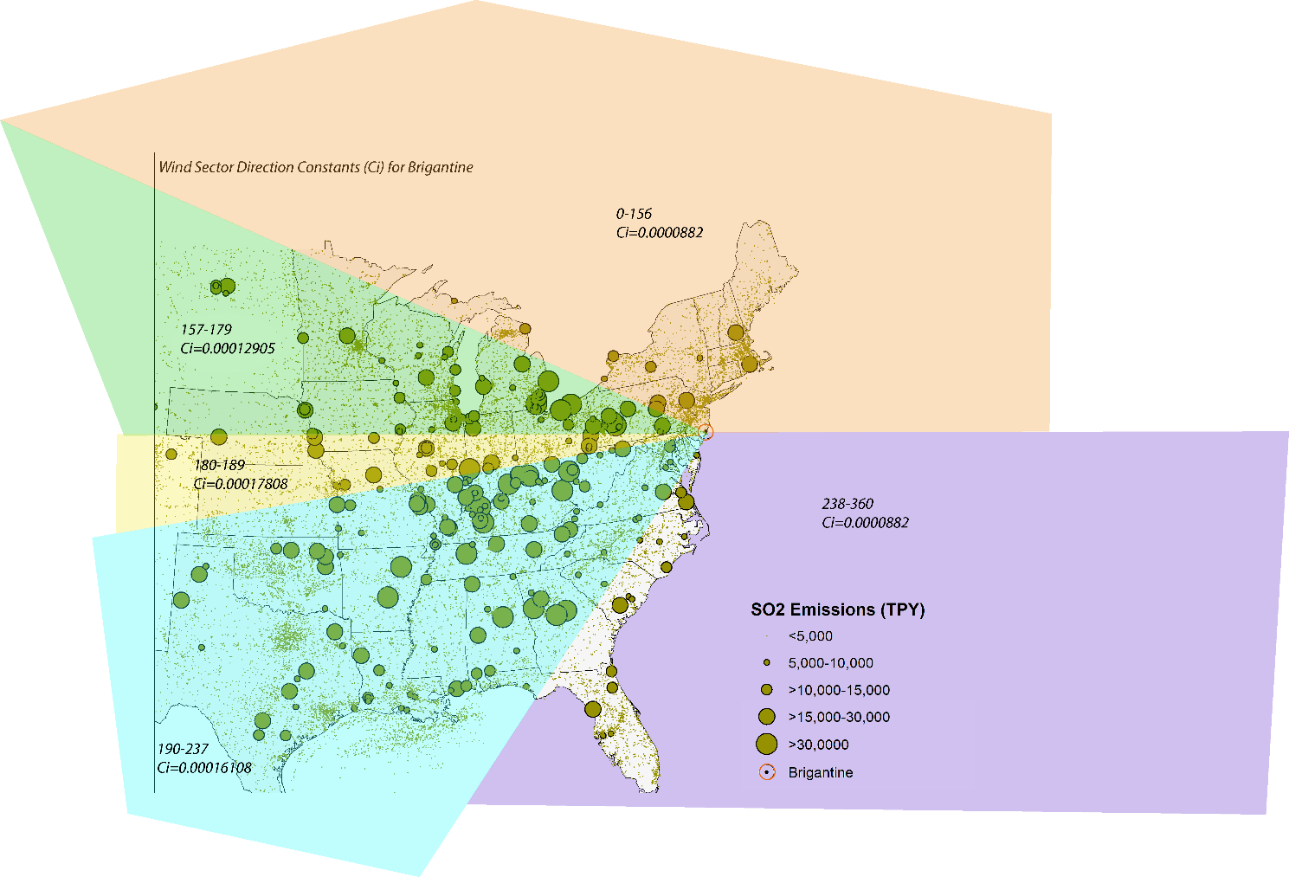

### Projected 2018 Contribution Estimates

The point contribution analysis was repeated for the point sector of the MARAMA α2 2018 inventory. The purpose of this analysis is to calculate a best estimate of with our most current understanding of the “start” year for the next regional haze SIP. Thereby reducing the efforts to further analyzed sources, which are known to significantly reduce emissions or no longer exist by 2018. The summation of the individual contributions by state resulted in an overall decrease in the total contributions by 2018 and the relative rankings did reshuffle for 2018, see Table 4 below.

Table 4. States with the Five Greatest Point Contributions in 2011 and Projected for 2018

|  | | **2011\*** | | **2018\*** | |
| --- | --- | --- | --- | --- | --- |
| **Receptor** | **Rank** | **State** | **Contribution** | State | Contribution |
| **Acadia** | **1** | OH | 0.091941355 | PA | 0.03442676 |
| **2** | PA | 0.065000429 | OH | 0.030218026 |
| **3** | IN | 0.050261661 | TX | 0.027290416 |
| **4** | MI | 0.042254566 | MO | 0.022326675 |
| **5** | IL | 0.031767801 | IN | 0.022200948 |
| **Brigantine** | **1** | OH | 0.143782214 | PA | 0.066174833 |
| **2** | PA | 0.127168402 | OH | 0.043255256 |
| **3** | IN | 0.060995943 | TX | 0.033915703 |
| **4** | KY | 0.048691472 | MD | 0.033394815 |
| **5** | TX | 0.03855251 | IN | 0.02723641 |
| **Dolly Sods** | **1** | OH | 0.304332742 | WV | 0.080326515 |
| **2** | PA | 0.156460896 | PA | 0.079466227 |
| **3** | WV | 0.121920177 | OH | 0.07326551 |
| **4** | IN | 0.091857237 | TX | 0.034729442 |
| **5** | KY | 0.069838976 | KY | 0.034046795 |
| **Great Gulf** | **1** | OH | 0.073746721 | PA | 0.028538138 |
| **2** | PA | 0.052415185 | OH | 0.025792798 |
| **3** | IN | 0.045361066 | TX | 0.02124918 |
| **4** | MI | 0.035254865 | IN | 0.021009177 |
| **5** | IL | 0.027097205 | MO | 0.01919794 |
| **James Face** | **1** | OH | 0.21967166 | OH | 0.059720444 |
| **2** | IN | 0.088060923 | PA | 0.04587869 |
| **3** | PA | 0.086371599 | TX | 0.03592808 |
| **4** | KY | 0.072636643 | KY | 0.034641141 |
| **5** | VA | 0.057416645 | IN | 0.033171851 |
| **Lye Brook** | **1** | OH | 0.114401027 | PA | 0.049709278 |
| **2** | PA | 0.098398004 | OH | 0.035424463 |
| **3** | IN | 0.051105607 | TX | 0.027899648 |
| **4** | MI | 0.044568087 | IN | 0.022562486 |
| **5** | NY | 0.032786194 | MO | 0.020612201 |
| **Moosehorn** | **1** | OH | 0.08457113 | PA | 0.028814579 |
| **2** | PA | 0.053933613 | OH | 0.028212134 |
| **3** | IN | 0.047024234 | TX | 0.026652076 |
| **4** | MI | 0.038105112 | MO | 0.022926812 |
| **5** | IL | 0.031793931 | IN | 0.020562191 |
| **Shenandoah** | **1** | OH | 0.223136587 | PA | 0.066894227 |
| **2** | PA | 0.129388586 | OH | 0.058558198 |
| **3** | IN | 0.07666613 | WV | 0.038467176 |
| **4** | WV | 0.063798543 | TX | 0.032531606 |
| **5** | KY | 0.057891393 | IN | 0.02970615 |

The Q/d contribution analysis showed a promising downward trend at all of the class I areas with IMPROVE monitors in MANE-VU, which is consistent with the ambient air quality measurements. Contributions decreased at all of the class I areas from 2011 to 2018, both the maximum and average state point source contributions were reviewed, See Figure 5. The contributions of the states with the largest point contributions remain fairly consistently in the top 5 through New York and Virginia do drop considerably in ranking when they were in the top 5 for 2011, See Figure 6.

Figure 5: Average and maximum state point source contribution to monitored class I areas for 2011 and 2018



Figure 6. Total point contributions (and percent of total contribution in labels) for 2011 actual and 2018 projections for state in OTC modeling domain.

|  |  |
| --- | --- |
|  | **Acadia** |
|  | **Brigantine** |
|  | **Great Gulf** |
|  | **Lye Brook** |
|  | **Moosehorn** |

Electric Generating Units (EGUs) that report emissions to the Clean Air Markets Division (CAMD) as a whole still account for the majority of the sulfate contributions to all of the Class I Areas examined (approximately 70% in all cases). Other point sources and non-reporting EGUs (small EGUs) produce the bulk of the remaining contribution. Emissions from oil and gas, refueling, and ethanol point sources have negligible impacts on the monitored Class I areas. Details as to the magnitude and relative importance of 2018 projected emissions from each point source sector can be observed in Figure 7 and Figure 8, respectively. Figure 9 emphasizes the outsized role of coal EGUs on impact, since nine of the top ten EGU SCCs in terms of projected 2018 impact are from coal powered EGUs (the other SCC in the top ten is associated with oil powered EGUs).

Figure 7: Impact on Class 1 Areas by Point Sectors

Figure 8: Relative Impact on Class 1 Areas by Point Sectors

Figure 9: Relative Impact of EGU Point Source SCCs on Acadia, Brigantine, Great Gulf, Lye Brook, and Moosehorn (inner to outer)

## Conclusions

The 2015 analyses; 2011 state total emissions, 2011 point emissions and the 2018 point emissions, each provide a unique insight to the contribution of each state and source sector the MANE-VU and neighboring class I areas. This report is the summary and is a starting point for the states in the region to assess their contributions to each neighboring class I area and for the class I areas state to further address the appropriate next steps in tandem with the other analyses available.

The summary of the results presented above illuminated two approaches a geographic approach and source sector approach. Geographically, all three of the 2015 analyses resulted in two top contributors, Ohio and Pennsylvania. The remaining state rankings varied by class I area and by analysis type (total emissions vs. point only emissions). The source sector approach, determined that EGUS (more specifically coal EGUs) still dominated the contributions. While emissions have and are projected to decrease in 2018, see Figure 10 , further work is needed to accomplish to visibility goals for 2064 and the resulting near term goals for the next ten-year planning cycle.

Figure . 2011 and 2018 Point Emissions

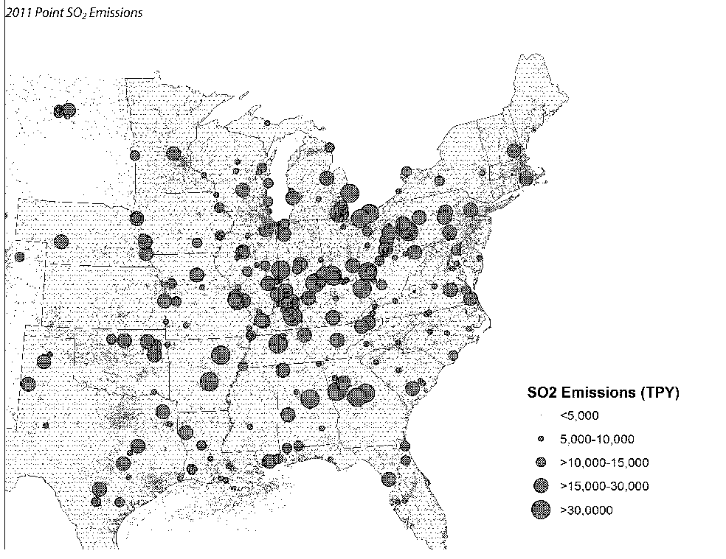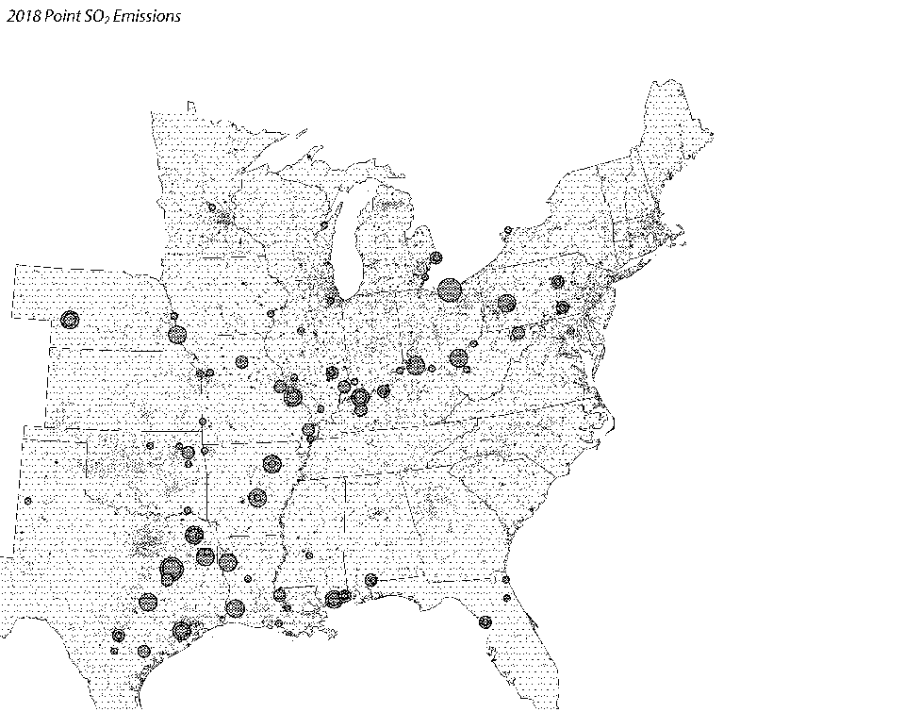

1. EPA, 2015. *Interagency Work Group on Air Quality Modeling Phase 3 Summary Report: Near-Field Single Source Secondary Impacts.* <http://www3.epa.gov/ttn/scram/11thmodconf/IWAQM3_NFI_Report-07152015.pdf>
2. NESCAUM, 2006. *Contribution to Regional Haze in the Northeast and Mid-Atlantic United States.* <http://www.nescaum.org/topics/regional-haze/regional-haze-documents>
3. NESCAUM, 2012. *Contributions to Regional Haze in the Northeast and Mid-Atlantic United States: Preliminary Update through 200*7. <http://www.nescaum.org/topics/regional-haze/regional-haze-documents>
4. MANE-VU, 2015. *Recommendation on Sectors to Review as Part of the Four-Factor Analysis Based on an Emission Inventory Analysis of SO2 & NOX. Appendix B.,*